论文列表
年度 | 出处 | 主题
2017 | J. Membr. Sci. 2017, 537:111–118 (1 September 2017) | Selective removal of halides from spent zinc sulfate electrolyte by diffusion dialysis
2017 | J. Membr. Sci. 2017, 525:229–239 (1 March 2017) | 磺化PBI膜的制备及其在全钒液流电池中的应用 (Co-authored with Prof. Fang@SJTU)
2017 | Materials & Design 2017, 113:149–156 (5 January 2017) | 全钒液流电池体系中石墨烯分离皮层增加了多孔薄膜的氢离子选择透过性
2015 | J. Membr. Sci. 2015, 493:28–36 (29 June, 2015) | 利用电渗析法纯化生产无盐染料酸性蓝9
2015 | ACS Appl. Mater. Interfaces 2015, 7(19):10534–10540 (May 4, 2015) | γ-Fe2O3包覆的多孔金纳米线的制备及其气体传感性质研究
2015 | Desalination 2015, 359:52–58 (2 March, 2015) | 可为微小海岛提供淡水的能量自给式自脱盐系统
2014 | Ind. Eng. Chem. Res. 2014, 53(34):13467–13474 (18 August, 2014) | 集成超滤和双极膜电渗析技术实现原子经济的超高碱度聚合铝盐绿色生产新工艺
2014 | 水处理技术 2014, 40(3):44–48 (Mar. 2014) | 基于膜分离的电极箔行业减排降耗过程研究
2013 | J. Membr. Sci. 2013, 432:90–96 (1 April, 2013) | 铝箔行业废酸零排放回收处理过程: 扩散渗析和双极膜电渗析技术的集成
2012 | Ind. Eng. Chem. Res. 2012, 51(34):11201–11206 (17 August, 2012) | 利用电解方法从AlCl3生产纯净Al13氯化物

Selective removal of halides from spent zinc sulfate electrolyte by diffusion dialysis
J. Membr. Sci. 2017, 537, Pages 111–118 (1 September 2017)
By Hui-Fang Xiao, Qing Chen, Huan Cheng, Xiu-Min Li, Wen-Meng Qin, Bao-Sheng Chen, Dong Xiao, Wei-Ming Zhang*
j.memsci.2017.05.009, fulltext mmc1.xlsx
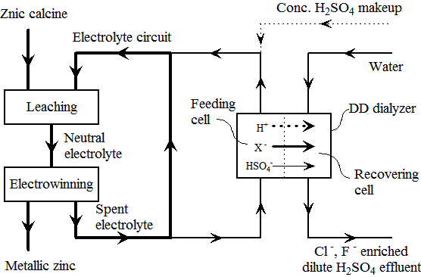
Zinc metal is mainly produced by a hydrometallurgical process, in which zinc electrolyte is recirculated, and impurities especially halides are accumulated then, which have dreadful impacts on the process and product. Until now numerous efforts have been made to remove halides from the electrolyte, but none of them are fully satisfying, and it is still a big issue for the industry. As a conventional membrane technology, diffusion dialysis (DD) is originally designed to recover free acid from acid-salt mixture by concentration gradient. In this work, we proposed a novel process to selectively remove these halide impurities from the spent zinc electrolyte by DD directly. Significant Cl- and F- permselectivities over HSO4- are observed in this process. The removal efficiencies are as high as 50–70% and 30–42% for chloride and fluoride, respectively, while the zinc loss is less than 1%. The flow intensity in the current work is much higher than that in conventional DD, which reduces the overall cost immensely. The mechanism of this selective mass transfer is also studied intensively to understand influence of flow intensity, charge number and hydrated radii of ions on the permselectivity. The results here are not confined to provide a superior method to remove halide impurities for the zinc industry, but also extend new applications and deepen understandings for the well-established DD process in selective ion separation. This capability is very likely to become a new growth point and future direction for the DD process besides acid/alkali recovery.

Preparation of covalently cross-linked sulfonated polybenzimidazole membranes for vanadium redox flow battery applications
J. Membr. Sci. 2017, 525, Pages 229–239 (1 March 2017)
By Zijun Xia, Libin Ying, Jianhua Fang*, Yu-Yu Du, Wei-Ming Zhang*, Xiaoxia Guo, Jie Yin
j.memsci.2016.10.050, local fulltext
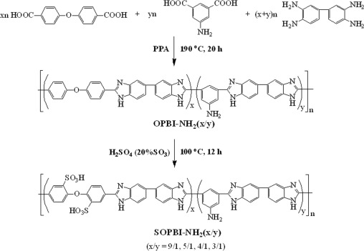
A series of polybenzimidazole copolymers with varied content of pendant amino groups have been synthesized by condensation polymerization of 4,4′-dicarboxydiphenyl ether (DCDPE), 5-aminoisophthalic acid (APTA) and 3,3′-diaminobenzidine (DAB) in polyphosphoric acid at 190 °C for 20 h. The resulting copolymers undergo post-sulfonatation in fuming sulfuric acid at 100 °C yielded the highly sulfonated polybenzimidazoles (SOPBI-NH2(x/y), ‘x/y’ refers to the monomer molar ratio of DCDPE to APTA). A series of covalently cross-linked membranes (CSOPBI-NH2(x/y)) with good mechanical properties are fabricated by solution cast technique using bisphenol A epoxy resin as a cross-linker. The CSOPBI membranes show 3–4 orders of magnitude lower VO2+ permeability and 6–30 times higher ion diffusion selectivity (proton vs. VO2+) than Nafion117. The charge-discharge behaviors of the vanadium redox flow batteries (VRBs) assembled with the CSOPBI-NH2(x/y) membranes and Nafion 117 are investigated and compared. The VRBs assembled with the CSOPBI membranes exhibit significantly higher columbic efficiency and lower self-discharge rate than that assembled with Nafion 117 owing to the extremely lower vanadium cations crossover of the former. The VRB assembled with the CSOPBI-NH2(9/1) membrane exhibits fairly high energy efficiency (~85% at 60 mA cm−2) and little decay in performance is observed after 300 charge-discharge cycles.

Graphene enhances the proton selectivity of porous membrane in vanadium flow batteries
Materials & Design 2017, 113, pp 149–156 (5 January 2017)
By Qing Chen, Yu-Yu Du, Kai-Min Li, Hui-Fang Xiao, Wei Wang* and Wei-Ming Zhang*
j.matdes.2016.10.019, local fulltext
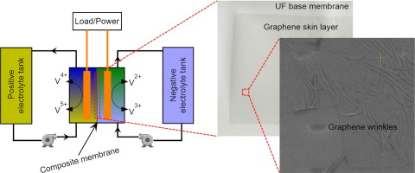
The vanadium flow battery (VFB) is one of the most promising technologies for large-scale energy storage, which has an enormous advantage in the stabilization and smooth output of renewable energy. As an essential separator in VFB, nanoporous membrane plays a key role in the final electrochemical performance, which requires both high H+ conductivity and low vanadium permeability. In this work, a novel graphene enabled porous membrane material has been successfully designed and fabricated by directly transferring several layers of graphene onto the surface of traditional polyethersulfone ultrafiltration membrane. The experimental results show that the graphene layers will impact the composite membranes performance in batteries. After three graphene single layers attached, the proton selectivity of membrane is significantly enhanced, and the overall battery efficiencies are improved by 10% at 20 mA cm− 2. Therefore, attaching graphene layers is a feasible and promising strategy to improve the performance of nanoporous membrane in VFB applications.

利用电渗析法纯化生产无盐染料酸性蓝9
J. Membr. Sci. 2015, 493, pp 28–36 (29 June, 2015)
By Chang Xue, Qing Chen, Yuan-Yuan Liu, Yu-Ling Yang, Dan Xu, Lixin Xue and Wei-Ming Zhang*
10.1016/j.memsci.2015.06.027 本地全文
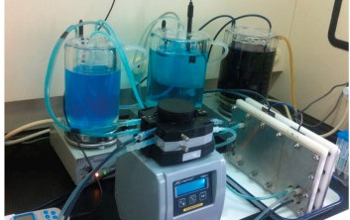
目前，染料粗产品的脱盐纯化主要是利用纳滤（NF）来完成的，NF对于从染料粗产品生产得到低盐产品（比如含盐量从10%纯化至0.5%）是非常有效的，并且已在染料行业大规模应用。然而，利用NF对低盐产品进行进一步纯化得到无盐产品（含盐量0.5%到0.025%以下）却依旧十分困难，究其原因是因为随着染料溶液中盐杂质含量的下降，NF系统的除盐性能也成比例迅速下降。在本文中我们提出了一种优化的电渗析过程来生产无盐染料，从而填补这一技术缺陷。在此过程中对染料分子与离子交换膜的相互作用，膜污染机理及缓解策略等都进行了详细的调查与理解。电渗析生产过程实现了系统性能的长期稳定，同时其总体运行成本也非常具有竞争力（优于NF）。最终生产得到的酸性蓝9的浓度可达200g/L，其中残留的Cl-浓度约为130 mg/L（96%去除），SO42-离子残留少于10mg/L，几乎能从染料溶液中被完全去除。这里我们提出的电渗析脱盐纯化过程提供了除NF以外的另一种可行且具有竞争力的方法，可以从低盐染料产品得到无盐产品。

γ-Fe2O3包覆的多孔金纳米线的制备及其气体传感性质研究
ACS Appl. Mater. Interfaces, 2015, 7 (19), pp 10534–10540 (May 4, 2015)
By Na-Mei Li, Kai-Min Li, Shun Wang, Ke-Qin Yang, Li-Jie Zhang, Qing Chen* and Wei-Ming Zhang*
10.1021/acsami.5b02087 本地下载: 全文
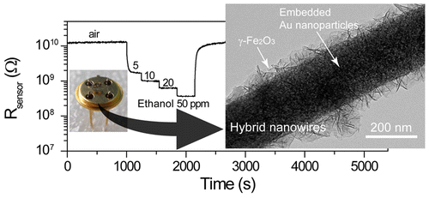
我们制备得到了具有规则形貌的具有γ-Fe2O3包覆的多孔金纳米线，同时详细表征了其形貌。这些复合纳米线具有疏松的γ-Fe2O3外壳，内嵌由微小Au纳米颗粒物（3–10 nm）组成的多孔Au纳米线。其结构与传统的贵金属表面修饰型纳米结构截然不同，其物理化学性质尤其是其催化及气敏特性也会有很大差异。该复合纳米线的制备是从Au-Fe合金纳米线开始的，通过在热碱液中溶出Fe组分对其进行去合金化并进行热处理得到最终产品。我们发现形成该复合结构的机理在于去合金化过程中Fe先溶解生成NaFeO2溶液，并在后期再水解生成γ-FeOOH包覆在剩余的多孔Au纳米线表面。进一步的材料表征，包括粉末衍射，SEM，TEM以及热重结果进一步证实了这种机理。复合纳米线内部的Au纳米颗粒与γ-Fe2O3壳层接触可产生纳米级开路肖特基接触，使γ-Fe2O3中电子向Au颗粒迁移，增加了半导体中电子耗尽层宽度，对提升半导体γ-Fe2O3壳层的气体敏感特性非常有帮助。气敏特性测试结果表明该复合纳米线对可燃性气体具有迅速，明显且可逆的响应。特别地，该材料对乙醇蒸汽显示了高的选择性和敏感性，是一种良好的乙醇敏感材料。

可为微小海岛提供淡水的能量自给式自脱盐系统
Desalination, 2015, 359, pp 52–58 (2 March, 2015)
By Qing Chen, Yuan-Yuan Liu, Chang Xue, Yu-Ling Yang, Wei-Ming Zhang*
相关论文在线下载: 10.1016/j.desal.2014.12.010
本地下载: 全文 附加材料-mmc1 mmc2 mmc3 mmc4 mmc5
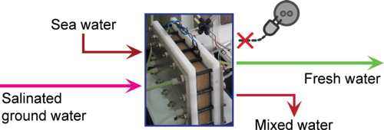
微小海岛上的地下淡水储备常常会受到海水入侵而盐度增加，造成口感变差甚至无法饮用。这时就需要对被污染的地下咸水进行脱盐处理来得到饮用淡水。然而，目前几乎所有的脱盐技术均需要稳定的外界能量输入，比如电能，而这也恰恰是海岛上（尤其是偏远海岛）所不具备的。在本文中我们提出了一种集成的自脱盐系统，该系统由阴阳离子交换膜交替组成，在该系统膜堆中我们同时集成了电渗析和反电渗析两种功能单元，使其同时具备回收海水及咸水中蕴含的浓差能，并将其应用于另一部分咸水的脱盐净化。该过程在热力学上是完全自发的，不需要任何额外能量输入。该系统是一种有前景的为偏远海岛提供淡水供应的技术。

集成超滤和双极膜电渗析技术实现原子经济的超高碱度聚合铝盐绿色生产新工艺
Ind. Eng. Chem. Res., 2014, 53(34), pp 13467–13474 (18 August, 2014)
By Qing Chen, Chang Xue, Wei-Ming Zhang*, Wei-Guo Song*, Li-Jun Wan, and Kun-Song Ma
相关论文在线下载: 10.1021/ie5023546
本地下载: 全文
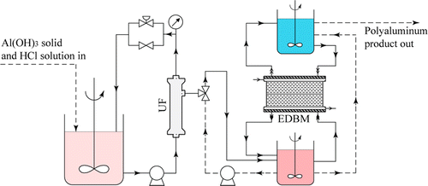
高纯超高碱度的聚合铝盐产品，通常由在酸性溶液中氧化金属Al得到。这个过程在化学上以及经济上显然是不高效的，因为首先Al资源被电解还原为金属Al，然后又被演化得到聚合氯化铝产品。在本文中，我们设计实现了一种可直接在常温常压下从Al(OH)3及酸来生产得到高碱度的聚合铝盐产品的集成系统。在该系统中超滤和双极膜模块协同工作，首先Al(OH)3和酸在一个混合罐中直接反应得到铝盐（如AlCl3），紧接着生成的铝盐以纯溶液的形式被超滤装置分离出来，并被送入一个双极膜电渗析器进行处理已得到高碱度聚合铝盐及副产物回收酸。这些回收酸会被送回混合反应罐再次与Al(OH)3反应并被重新利用。该超滤-双极膜电渗析集成系统可实现聚合铝盐的原子经济性生产，是一种纯粹的绿色生产工艺。

基于膜分离的电极箔行业减排降耗过程研究
By 陈庆 张伟明
水处理技术 2014, 40(3), pp 44-48 (Mar. 2014)
出版社链接 全文
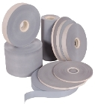
提出了一种基于膜分离技术的新思路来解决电极箔行业在生产过程中所产生的大量腐蚀废酸及清洗废水的排放问题,这些工业废液中的资源可以被分离出来并得到重复利用。通过系统集成,笔者利用扩散渗析及双极膜电渗析联用技术,实现了行业腐蚀废酸零排放的回收处理;同时借助频繁倒极电渗析技术,还实现了己二酸铵清洗废水中药剂及纯水资源的回收。实验结果表明,这些新过程的开发有望改变电容箔行业高消耗、高污染的现状,大大减少社会资源消耗总量及污染物排放总量,实现行业可持续发展。
关键词： 电极箔 膜分离 扩散渗析 电渗析 双极膜 腐蚀废酸 清洗废水 回收

铝箔行业废酸零排放回收处理过程: 扩散渗析和双极膜电渗析技术的集成
J. Membr. Sci., 2013, 432, pp 90–96 (1 April, 2013)
论文在线下载: 10.1016/j.memsci.2013.01.016
本地下载: 全文 附加材料-mmc1
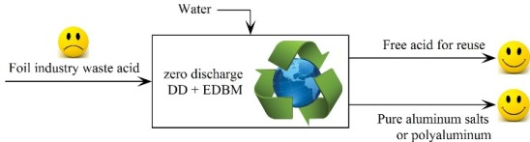
我们提出并实现了一种铝箔行业废酸零排放回收处理工艺，可完全回收铝箔废酸中含有的游离酸及铝资源。在此工艺中我们集成耦合了扩散渗析及双极膜电渗析工艺，首先废酸中的绝大部分游离酸在扩散渗析器中被回收；同时得到的处理残液（废盐液）被送入双极膜电渗析器进行进一步碱化，得到纯净的铝盐产品及第二部分回收酸。经过这套工艺处理后，原始废酸中所有的化学组分均被回收得到纯净化学品，实现了废酸的零排放。我们还对该工艺的详细成本进行了核算，其结果显示该过程仅在化学品回收收益上就可实现盈利，更不用说额外的环境收益了。该集成处理工艺可帮助铝箔行业实现可持续发展。

利用电解方法从AlCl3生产纯净Al13氯化物
Ind. Eng. Chem. Res., 2012, 51 (34), pp 11201–11206 (17 August, 2012)
相关论文在线下载: 10.1021/ie301048k
本地下载: 全文
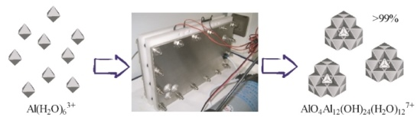
我们设计实现了一种电解系统，可通过电解AlCl3溶液得到超高碱度，甚至是纯净的Al13产品（碱度最高的聚合铝盐产品，也是其有效成分）。AlCl3同时也是铝箔行业副产品之一，该系统可以以较低的成本（$1.09/kg,以Al2(OH)5Cl·2H2O计算）将AlCl3转化为纯净Al13产品。同时我们还考察优化了电解温度及电流密度对生产过程的影响。Ferron比色实验及27Al核磁结果均表明最终产品中Al13含量不低于99%。离子色谱的结果表明最终产品中Cl-占96.5%，剩余阴离子主要为电解产生的ClO3-离子。该系统是目前已知的直接生产得到纯净Al13产品的方法。为了得到如此之高的纯度，其它方法均需要采取额外的提纯步骤。本文中提出的Al13生产方法可应用于Al13产品的大规模生产，以满足催化及化妆品行业对高纯度Al13产品的需要。

